NAME: Abdukholik Tukhtamishev

This lecture report will focus on the subjective evaluation of the model inserting taxes on the perfectly competitive market and the influence of taxes on demand for labour, profits and production on a typical firm. You will have instant visualization of many functions. Based on them, you should assess their external validity. Remember that the numbers (p, w) are artificial and do not interpret them – it is a problem of calibration of the function. You have to focus on the behaviour of the functions and interpret their behaviour.

In your exam, in some tasks, the input is personalised by **N1, N2, N3, N4, N5** the sequence of the first 5 digits from your student ID. Today we use only **N1** and **N5**. But it will be enough to create many versions of the task. Only input it into the task and run the code. [sometimes to improve the quality of the graph you should change the graph option – intervals of drawing which are bolded in code].

**Problem:**

The production function of a typical company producing boxes of candies can be approximated by the formula Y(L)=500*(N1+N5 + 20)L^(0.5). The company operated in perfectly competitive conditions. The price of the box of candies is given p = (N1+N5 + 5). The market wages in this sector are w = 5100. How will the introduction of a tax on the firm (considered producing an unhealthy product) affect the demand for labour at a typical company? What will be the company’s production and profit levels? What is the optimal tax rate that maximizes tax revenue for the government? Furthermore, how will the optimal tax rate impact the company?

**1) Extended Approach from Intermediate Microeconomics: calculate at least two equilibrium points and compare them.**

The government believes that significant taxation on candy production is necessary. Four options are being considered:

a) A 20% sales tax on candy, based on the value of the product sold ( ad valorem tax on sales)

b) A 25% tax on profits.

c) A fixed tax of $3 per box of candies sold (per-unit excise tax)

d) A wage tax where employers must pay an additional $300 per employee, as the government believes wages are too high in this sector.

The government can pursue three different objectives:

1. Fiscal – Maximizing tax revenues.
2. Social – Minimizing sugar consumption and reducing candy production.
3. Employment Stability – Maintaining the same number of workers employed.

Which tax option is the best for achieving each of the three goals (1, 2, and 3)? Is it possible to achieve all three goals simultaneously, or at least two out of three? Additionally, which of these taxes would be easiest to implement with the least social resistance? Provide a reasoned argument for your subjective assessment based on results.

Check and correct the codes: i) insert your N-s ii) see if the taxation method declarations match the profit function record. iii) if there are any errors in the code.

Then compare the results you have, squeeze as much as you can from this information. How big is this tax burden - you can determine this by comparing it with other profit components. How does this model behave? You can experiment with the parameters.

|  |  |  |  |
| --- | --- | --- | --- |
| A | d | c | b |
| kill(all);  assume(w >0,L>0,p>0,t>0);  N1:4;  N5:8;  w: 5100;  A: 500;  t: 0.2;  p: (N1+ N5 + 5);  /* enter the production function */  Y: A*(N1+N5 + 20)*L^(0.5);  /* enter the profit function */  Profit: p*(1-t)*Y - w*L$  /* calculate f.o.c*/  eq1: diff(Profit,L,1) = 0;  float(solve (eq1,L));  L : rhs(%[1]);  /* outputs */  print("t = ", ''t) $  print("p = ", ''p) $  print("L* = ", ''L) $  print("Y* = ", ''Y) $  print("Π* = ", ''Profit) $  print("T* = tpY* = ", '' t*p*''Y) $  print("Cost of work = ", '' w*''L) $  print("Revenue = ", '' p*''Y) $ | kill(all);  assume(w >0,L>0,p>0,t>0);  N1:1;  N5:3;  w: 5100;  A:500;  t: 300;  p: (N1+ N5 + 5);  /* enter the production function */  Y: A*(N1+N5 + 20)*L^(0.5);  /* enter the profit function */  Profit: p*Y - (w+t)*L$  /* calculate f.o.c*/  eq1: diff(Profit,L,1) = 0;  float(solve (eq1,L));  L : rhs(%[1]);  /* outputs */  print("t = ", ''t) $  print("p = ", ''p) $  print("L* = ", ''L) $  print("Y* = ", ''Y) $  print("Π* = ", ''Profit) $  print("T* = t*L* = ", '' t*''L) $  print("Cost of work = ", '' (w+t)*L )$  print("Revenue = ", '' p*''Y) $ | kill(all);  assume(w >0,L>0,p>0,t>0);  N1:4;  N5:8;  w: 5100;  A:500;  t: 3;  p: (N1+ N5 + 5);  /* enter the production function */  Y: A*(N1+N5 + 20)*L^(0.5);  /* enter the profit function */  Profit: (p*Y - w*L - t*Y)$  /* calculate f.o.c*/  eq1: diff(Profit,L,1) = 0;  float(solve (eq1,L));  L : rhs(%[1]);  /* outputs */  print("t = ", ''t) $  print("p = ", ''p) $  print("L* = ", ''L) $  print("Y* = ", ''Y) $  print("Π* = ", ''Profit) $  print("T* = t*Y* = ", '' t*''Y) $  print("Cost of work = ", '' w*L )$  print("Revenue = ", '' p*''Y) $ | kill(all);  assume(w >0,L>0,p>0,t>0);  N1:4;  N5:8;  w: 5100;  A:500;  t: 0.25;  p: (N1+ N5 + 5);  /* enter the production function */  Y: A*(N1+N5 + 20)*L^(0.5);  /* enter the profit function */  Profit: (1 - t)* (p*Y - w*L)$  /* calculate f.o.c*/  eq1: diff(Profit,L,1) = 0;  float(solve (eq1,L));  L : rhs(%[1]);  /* outputs */  print("t = ", ''t) $  print("p = ", ''p) $  print("L* = ", ''L) $  print("Y* = ", ''Y) $  print("Π* = ", ''Profit) $  print("T* = t*Profit* = ", '' t*''Profit) $  print("Cost of work = ", '' w*''L) $  print("Revenue = ", '' p*''Y) $ |

**Analysis Advanced Microeconomics style:**

Although we are using a Cobb-Douglas production function as a simplification, ideally, we should have a more general form of the production function that exhibits specific fundamental properties (see the lecture example from the textbook). Our objective is to derive and analyze a general solution in symbolic form. This will allow us to determine how our endogenous variables respond to exogenous factors (such as prices and taxes) or other parameters.

We aim to explore the effects of taxation on i) labour demand and ii) the supply of candy. In this case, we calculate Y as an indirect function of L* (by substituting the labour demand function into the production function). We will then examine the first derivative of this function with respect to the relevant variable.

Our focus will only be on analyzing the effects of the ad valorem sales tax on labour and production. Interpret the analytical result obtained.

Isn’t it helpful to have a shortcut similar to Hotelling’s Theorem? I won’t make you go through this type of analysis in every lecture, but just imagine what you're missing!

|  |
| --- |
| kill(all)$  assume(A>1,w >0,L>0,p>0,t>0, t<1, a>0,a<0)$  declare (a, noninteger)$  /* enter the production function */  Y: A*L^(a)$  /* enter the profit function */  Profit: p*(1-t)*Y - w*L$  /* calculate f.o.c*/  eq1: diff(Profit,L,1) = 0$  float(solve (eq1,L))$  L : rhs(%[1])$  L_star: ''L$  Y_star : ''Y$  print("L* = ", ''L_star) $  print("Y* = ", ''Y_star) $  print("dL*/dt = ", ''diff(L_star,t,1)) $  print("dY*/dt = ", ''diff(Y_star,t,1)) $ |

**3)** **Application of Felix Klein's Postulates**

Rather than focusing solely on theorems, proofs, or general results in symbolic form, you can experiment with models and attempt to address the fundamental question of external validity. The examination of internal validity can be found in advanced microeconomics textbooks.

This task involves a subjective assessment of whether the models are externally valid. The key takeaway is that the only definitive conclusions you can draw are whether something increases, decreases, or remains unchanged (the exact numbers are irrelevant). What truly matters is how the function behaves, as this reveals the underlying dynamics of the system.

|  |  |  |
| --- | --- | --- |
| kill(all);  assume(w >0);  N1:4;  N5:8;  p: (N1+ N5 + 5);  /* enter the production function */  Y: 500*(N1+ N5 + 20)*L^(0.5);  /* enter the profit function */  Profit: p*Y - w*L;  /* calculate f.o.c*/  eq1: diff(Profit,L,1) = 0;  float(solve (eq1,L));  L : rhs(%[1]);  draw2d(  xlabel = "w",  ylabel = "L",  explicit(ev(L), w,**2000**,**8000**)); | kill(all);  assume(w >0);  N1:4;  N5:8;  p: (N1+ N5 + 5);  /* enter the production function */  Y: 500*(N1+ N5 + 20)*L^(0.5);  /* enter the profit function */  Profit: p*Y - w*L;  /* calculate f.o.c*/  eq1: diff(Profit,L,1) = 0;  float(solve (eq1,L));  L : rhs(%[1]);  /* calculate elasticity f(w)*/  e_L: diff(ev(L),w,1)* (w/L);  draw2d(  xlabel = "w",  ylabel = "Elasticity of L(w) with respect to w",  explicit(ev(e_L), w,**2000**,**4000**)); | We can easily reverse the relation and analyze the demand for labour as a function of wages L(w). We can calculate and visualize the elasticity of labour E(w) with respect to wages (w). |
| kill(all);  assume(w >0);  assume(1- t >0);  **N1:4;**  **N5:8;**  w:5100;  p: (N1+ N5 + 5)*(1-t);  /* enter the production function */  Y: 500*(N1+ N5 + 20)*L^(0.5);  /* enter the profit function */  Profit: p*Y - w*L;  /* calculate f.o.c*/  eq1: diff(Profit,L,1) = 0;  float(solve (eq1,L));  L : rhs(%[1]);  draw2d(  xlabel = "t",  ylabel = "L",  explicit(ev(L), t,0,0.99)); | kill(all);  assume(w >0);  assume(1- t >0);  **N1:4;**  **N5:8;**  w:5100;  p: (N1+ N5 + 5)*(1-t);  /* enter the production function */  Y: 500*(N1+ N5 + 20)*L^(0.5);  /* enter the profit function */  Profit: p*Y - w*L;  /* calculate f.o.c*/  eq1: diff(Profit,L,1) = 0;  float(solve (eq1,L));  L : rhs(%[1]);  /* calculate elasticity f(w)*/  e_L_t: diff(ev(L),t,1)* (t/L);  draw2d(  xlabel = "t",  ylabel = "Elasticity of L(t) with respect to t",  explicit(ev(e_L_t), t,0,0.99)); | How taxes influence demand for labour? We can calculate and visualize the elasticity of labour L(t) with respect to tax rate (t). |
| kill(all);  assume(w >0);  assume(1- t >0);  **N1:4;**  **N5:8;**  w:5100;  p: (N1+ N5 + 5)*(1-t);  /* enter the production function */  Y: 500*(N1+ N5 + 20)*L^(0.5);  /* enter the profit function */  Profit: p*Y - w*L;  /* calculate f.o.c*/  eq1: diff(Profit,L,1) = 0;  float(solve (eq1,L));  L : rhs(%[1]);  draw2d(  xlabel = "t",  ylabel = "Profit",  explicit(ev(Profit), t,0,0.99)); | kill(all);  assume(w >0);  assume(1- t >0);  **N1:4;**  **N5:8;**  w:5100;  p: (N1+ N5 + 5)*(1-t);  /* enter the production function */  Y: 500*(N1+ N5 + 20)*L^(0.5);  /* enter the profit function */  Profit: p*Y - w*L;  /* calculate f.o.c*/  eq1: diff(Profit,L,1) = 0;  float(solve (eq1,L));  L : rhs(%[1]);  draw2d(  xlabel = "t",  ylabel = "Y",  explicit(ev(Y), t,0,0.99)); | How taxes influence profit and production? |
| kill(all);  assume(w >0);  assume(1- t >0);  N1:4;  N5:8;  w:5100;  p: (N1+ N5 + 5)*(1-t);  /* enter the production function */  Y: 500*(N1+ N5 + 20)*L^(0.5);  /* enter the profit function */  Profit: p*Y - w*L;  /* calculate f.o.c*/  eq1: diff(Profit,L,1) = 0;  float(solve (eq1,L));  L : rhs(%[1]);  /* calculate tax revenue T(t) as a function of t */  T: t*p*ev(Y);  draw2d(  xlabel = "t",  ylabel = "T",  explicit(ev(T), t,0,0.99)); |  | It is a sort of Laffer curve. It is the tax revenue function T(t) with respect to the tax rate. |
| kill(all);  kill(all)$  assume(A>1,w >0,L>0,p>0,t>0, t<1, a>0,a<0)$  declare (a, noninteger)$  N1:4;  N5:8;  p: (N1+ N5 + 5);  w: 5100;  /* enter the production function */  Y: 500*(N1+ N5 + 20)*L^(a);  /* enter the profit function */  Profit: p*Y - ''w*L;  /* calculate f.o.c*/  eq1: diff(Profit,L,1) = 0;  float(solve (eq1,L));  L : rhs(%[1]);  draw2d(  xlabel = "a",  ylabel = "owner and labour incomes",  key = "labour expenses",  explicit(ev(w*''L), a,0.3,0.55),  key = "profit ",  color = red,  explicit(ev(''Profit), a,0.3,0.55)  ); |  | Finally, something to think about: how the division of income between owners and employees depends directly on the production function parameter. An interesting and very significant relationship. |

# Analysis and solutions

**N1=4, N5=8, P=17 (P=N1+N5+5= 4+8+5=17), Wage w=5100, ProdFunc: Y(L)=16 000*L^0.5 (Y(L)=500(N1+N5+20)L^0.5)**

**Total revenue= Y(L)*p**

**Cost= L*w**

**Profit: Y(L)*p-L*w**

1. How will introducing a tax on the firm (considered producing an unhealthy product) affect the demand for labour at a typical company?

Given that the company produces unhealthy products, the government should impose a tax on it to either discourage the company from producing unhealthy products or generate revenue. Imposing tax will affect the following operations: 1. Cost per unit of production will increase as the company is paying taxes. 2. The tax will effectively reduce the company’s marginal revenue of per box of candy as a part of the revenue going to the government instead of staying within the company. As long as the company is operating in a perfectly competitive market, the company will hire labour to the point where MRP (Marginal Revenue Product of Labour) >= wage.

MRP= MR (Marginal Revenue)*MPL (Marginal Product of Labour). The company’s reduced marginal revenue will result in a decrease in MRP. As we mentioned earlier, MRP >= wage in perfectly competitive markets. As it goes down, the company should hire fewer workers.

**Summary**

Reduced labour demand because of lower MRP  
Reduced output because of reduced labour demand

Lower profits as part of the revenue goes to the government

1. What is the optimal tax rate that maximizes tax revenue for the government?

In my opinion, tax on profits would not be optimal because firms may report lower profits intentionally to avoid tax liability, artificially increasing their expenses such as incentives, operational expenses, and reinvestment. There have been cases when companies engage in more aggressive accounting practices. Monitoring and auditing such firms to ensure accurate profit reporting is usually resource-intensive.

Applying excise tax is also not an optimal choice, I guess. However, it depends on the elasticity of demand for the product. Products like alcohol, tobacco, and other drugs usually come with inelastic demand meaning customers would buy anyway because of addiction and habits even if the price increased because of tax. As far as I am concerned, we don’t use candies on a daily basis as it is not an integral part of our diet. Hence, candies come with relatively elastic demand which makes the product sales unstable. Tax revenue from excise tax on candies fluctuates even resulting way much lower tax revenue for the government.

I think sales tax would work better than the abovementioned tax types but still, it depends on the demand. But generally, the government would earn a lot with the sales tax.

About payroll tax, I think this is the optimal one as the wages in this sector are too high. The government would generate substantial amounts of money consistently by applying the tax on wages. Wages are stable and predictable which makes payroll taxes reliable for the government.

**Summary**

Payroll Tax is an optimal choice for the government given the circumstances. Furthermore, how will the optimal tax rate impact the company?

1. How will the optimal tax rate impact the company?

As payroll tax is imposed on the firm, it will impact labour costs which leads to fewer hiring, limiting wage increases and bonuses. Payroll taxes typically involve contributions from both employers and employees, potentially increasing the total revenue without overly burdening either side. However, when applied too aggressively it will reduce the net pay potentially affecting the overall economic activity.

**Summary**

When applied in moderation, the payroll tax would provide consistent revenue for the government without affecting the overall economic relations.

# Tax options (a, b, c, d) and outcomes

1. A 20% sales tax on candy, based on the value of the product sold (ad valorem tax on sales)

I ran the given code on Maxima for Sales Tax and got the following results. According to the First-Order Condition Rule when Labor = 455, the company’s profit will be at its MAX

These are the rest of the results (Round numbers accordingly):

$$\begin{matrix}"t = "" "0.2" " \\ "p = "" "17" " \\ "L· =455.1111111111111" " \\ "Y· =341 333.3333333333" " \\ "Π· =2 321 066.6666666674" " \\ "T· = tpY· =1 160 533.3333333335" " \\ "Cost of work =2 321 066.6666666665" " \\ "Revenue = 5 802 666.666666666\end{matrix}$$

1. A 25% tax on profits.

I drew the following results upon running the code on the maxima

$$\begin{matrix}"t = "" "0.25" " \\ "p = "" "17" " \\ "L· =711.1111111111111" " \\ "Y· =426 666.6666666667" " \\ "Π· =2 720 000.0000000005" " \\ "T· = t·Profit· =680 000.0000000001" " \\ "Cost of work =3 626 666.6666666665" " \\ "Revenue =7 253 333.333333334\end{matrix}$$

1. A fixed tax of $3 per box of candies sold (per-unit excise tax)

I drew the following results upon running the code on the maxima

$$\begin{matrix}"t = "" "3" " \\ "p = "" "17" " \\ "L· =482.27604767397156" " \\ "Y· =351 372.54901960783" " \\ "Π· =2 459 607.843137255" " \\ "T· = t·Y· =1 054 117.6470588236" " \\ "Cost of work =2 459 607.843137255" " \\ "Revenue =5 973 333.333333333\end{matrix}$$

1. A wage tax where employers must pay an additional $300 per employee, as the government believes wages are too high in this sector.

I drew the following results upon running the code on the maxima

$$\begin{matrix}"t = "" "300" " \\ "p = "" "17" " \\ "L· =634.2935528120713" " \\ "Y· =402 962.9629629629" " \\ "Π· =3 425 185.1851851842" " \\ "T· = t·L· =190 288.06584362139" " \\ "Cost of work =3 425 185.185185185" " \\ "Revenue =6 850 370.370370369\end{matrix}$$

**Equilibrium Points**

Based on the codes we have probable equilibrium point for 20 % sales tax and $3 excise tax. In order to get the maximum profit, for both functions, we need similar labour force. When 20% sales tax is applied we need 455 labour force while for $3 tax we need 482 which means labour force is quite close in two cases rather than in other taxes. If we further continue our research, we will see that, the company earning similar profits and producing similar number of box of candies, 341 333 and 351 372 respectively. In summary if labour force is between 455 and 482, it gives us almost equilibrium results.

**Convexity of the production function**

The production function is said to be convex if its graph bulges upwards. In other words, the second derivative of the production function with respect to labor input is positive. This means that the marginal product of labor is increasing.

The convexity of the production function has several important implications. First, it means that the firm will always be better off by producing more output, up to the point where the marginal cost of production equals the marginal revenue. Second, it means that the firm's profit function will also be convex. This means that the firm's profit will be maximized at a single point, and that the firm will not be able to make a profit by producing too much or too little output.

**Influence of convexity on the profit function**

The convexity of the production function has a direct impact on the shape of the profit function. As we saw above, the profit function will also be convex. This means that the firm's profit will be maximized at a single point. This is in contrast to a concave production function, which would result in a non-convex profit function with multiple possible profit maximizing output levels.

The convexity of the profit function is important because it makes it easier for the firm to find its profit-maximizing output level. In a concave profit function, the firm might need to experiment with different output levels in order to find the one that maximizes its profit. In a convex profit function, the firm can simply produce as much as possible until its marginal cost equals its marginal revenue.

**Impact of Taxes on Profit**

The maxima code defines the profit function for a firm producing boxes of candies in a market with a tax rate (t). The profit function is given by Profit = pY - wL, where p is the price of a box of candies, Y is the output of the firm, w is the wage rate, and L is the labor input. The tax rate (t) affects the price of a box of candies, which in turn affects the firm's profit.

As the tax rate increases, the price of a box of candies decreases. This is because the firm must pass on the cost of the tax to consumers in the form of a higher price. However, a higher price will reduce the demand for boxes of candies. This reduction in demand will lead to a decrease in the firm's output, which in turn will decrease the firm's profit.

The magnitude of the decrease in profit will depend on the elasticity of demand for boxes of candies. If the demand is elastic, then a small increase in the tax rate will lead to a large decrease in the price of a box of candies, which will in turn lead to a large decrease in the firm's output and profit. Conversely, if the demand is inelastic, then a small increase in the tax rate will lead to a small decrease in the price of a box of candies, which will in turn lead to a small decrease in the firm's output and profit.

**Impact of Taxes on Production**

The maxima code also defines the production function for a firm producing boxes of candies. The production function is given by Y = 500(N1+ N5 + 20)L^(0.5), where N1 and N5 are the first and fifth digits of the student ID (474886 N1=4, N5=8), and L is the labor input. The tax rate (t) does not directly affect the production function. However, it does indirectly affect production by affecting the firm's profit.

As we saw above, an increase in the tax rate will lead to a decrease in the firm's profit. This decrease in profit may lead the firm to reduce its production in order to cut costs. The firm may also choose to substitute labor with other inputs, such as capital, in order to reduce its production costs.

The magnitude of the decrease in production will depend on the firm's cost structure and its profit margins. If the firm has high fixed costs, then it may be more reluctant to reduce production in response to a decrease in profit. Additionally, if the firm has high profit margins, then it may be more willing to accept a decrease in profit in order to maintain its production levels.

**Conclusion**

Taxes can have a significant impact on the profit and production decisions of firms. The magnitude of this impact will depend on the elasticity of demand for the firm's product, the firm's cost structure, and its profit margins. In general, however, an increase in the tax rate will lead to a decrease in profit and production.

*Government Goals*

1. Fiscal – Maximizing tax revenues.

2. Social – Minimizing sugar consumption and reducing candy production.

3. Employment Stability – Maintaining the same number of workers employed.

1. Which tax option is the best for achieving each of the three goals (1, 2, and 3)?

Given the situation, option c) (per-unite excise tax) would work for all three goals. However, it is difficult to satisfy all three goals with a single type of tax each goal has conflicting dynamics.

The amount of tax revenue generated by this type is relatively higher than b) and c) while only a bit lower than a). As far as social impact is concerned, the excise tax is often paid indirectly by consumers as the tax is embedded in the price of a product. Hence not everyone would be in favour of buying the product because of the increased price due to excise tax which prevents them from buying more. As a result, they might consume less of that product or even stop consuming it, leading to a drop in demand. As long as the demand decreases it may lead to reduced production. Regarding employment stability, usually, excise taxes don’t have a significant direct impact on employment so producers might not feel substantial change to alter employment. However, when applied high enough, it may lead to reduced production, leading to minor job cuts.

1. Is it possible to achieve all three goals simultaneously, or at least two out of three?

As we have mentioned above, not all three will be satisfied with a single type of tax. One way or another one of the goals may not be achieved. However, more than one tax type can be imposed in combination to achieve all three goals.

To maximize revenue, a government might impose a higher excise tax on candy or sugary products. However, at a certain point, if the tax becomes too high, it could lead to a drop in demand (especially if consumers turn to substitutes), which could eventually reduce total tax revenue as a result of reduced production and demand.

A high tax rate could successfully reduce sugar consumption and candy production, aligning with public health objectives. However, if demand drops sharply, it might decrease the tax revenue, as fewer products are sold. The higher the tax, the greater the risk that businesses may have to reduce production potentially leading to job cuts, negatively affecting the employment stability goal.

If we want to keep employment stable in the industry, we’d avoid a tax high enough to deter demand significantly. Keeping demand steady means maintaining production, but this also implies that sugar consumption remains relatively high, potentially conflicting with the social goal.

I used combinatorics for three goals: ab, ac, cb

ab) Fiscal and Social: A sales tax has a dual impact: it generates revenue while also being visible to consumers, which can subtly guide behaviour. The tax is more effective socially if it’s high enough to make consumers reconsider, but not so high that it causes a sharp drop in demand, which could eventually erode revenue. If companies face slightly lower demand due to the tax, they might modestly adjust production but likely won’t need drastic cuts, maintaining production levels stable enough for predictable tax income.

ac) Fiscal and Employment Stability: An excise tax is specifically effective because it targets the products that generate consistent demand, ensuring that the tax revenue remains relatively stable. Plus, the incremental cost passed on to consumers is less likely to disrupt demand drastically, making it easier to sustain current employment levels.

bc) Social and Employment Stability: A payroll tax directly increases the cost of labour, which can have a subtle impact on production without risking significant layoffs. This aligns with the goal of social impact by potentially reducing candy production over time, without causing severe job losses or instability in the labour market. Moreover, because payroll taxes are typically predictable, companies can factor them into their labour costs, allowing for more stable workforce planning.

1. Additionally, which of these taxes would be easiest to implement with the least social resistance?

I think profit tax would be easiest. Because excise tax is directly embedded in the product which means consumers will show resistance and unwillingness to accept it. Sales tax also increases the selling price of the product causing public objection against the policy. Payroll tax may not be objected heavily by the public it slightly affects the market price of a product. So profit tax on the other hand is not visible to the public and they don't care about the tax the company pays on profit earned. Consumers are generally less concerned with taxes that don’t immediately affect their wallet, making profit tax a “behind-the-scenes” approach with a lower likelihood of triggering public objections.

**Application of Felix Klein's Postulates:** We can easily reverse the relation and analyze the demand for labour as a function of wages L(w) We can calculate and visualize the elasticity of labour E(w) with respect to wages (w).

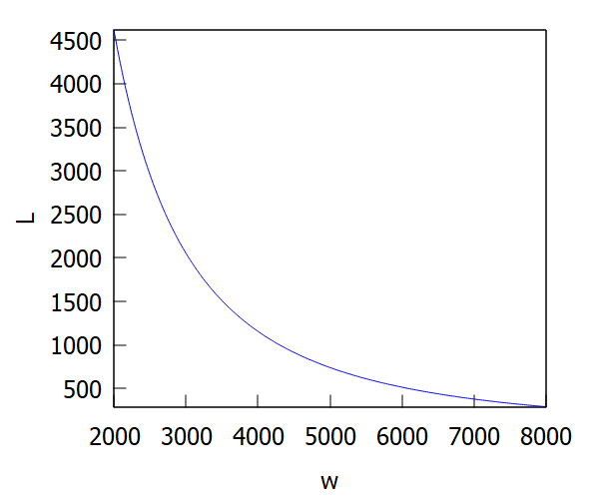

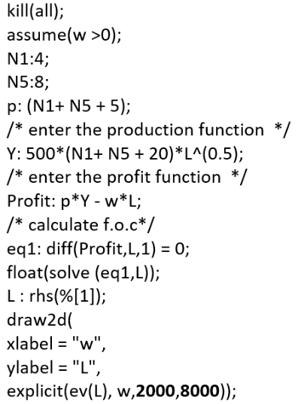

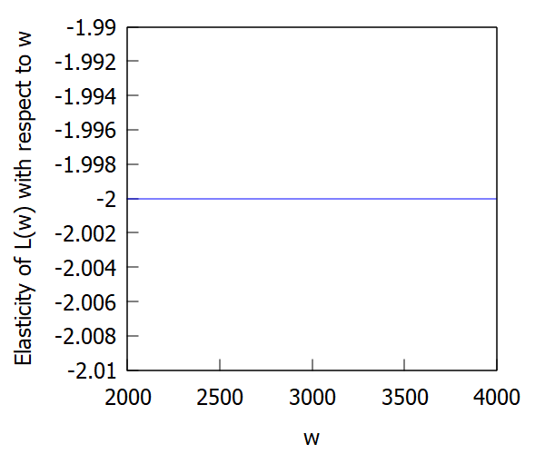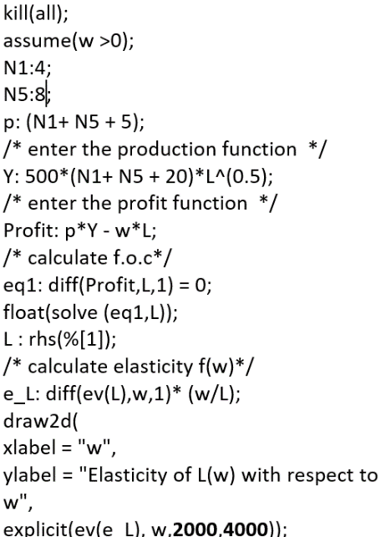

How taxes influence demand for labour? We can calculate and visualize the elasticity of labour L(t) with respect to tax rate (t).

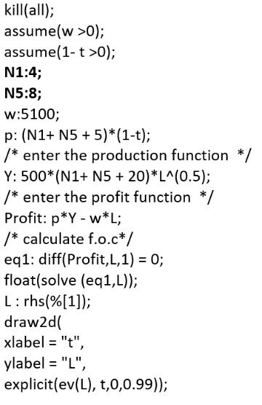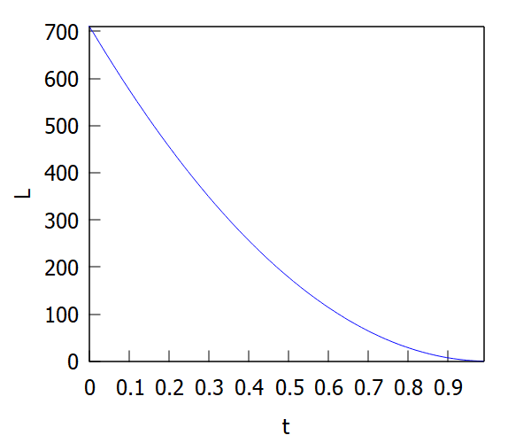

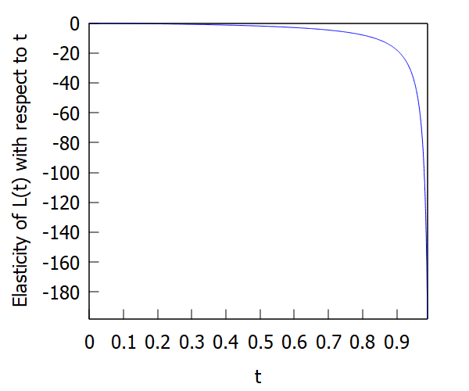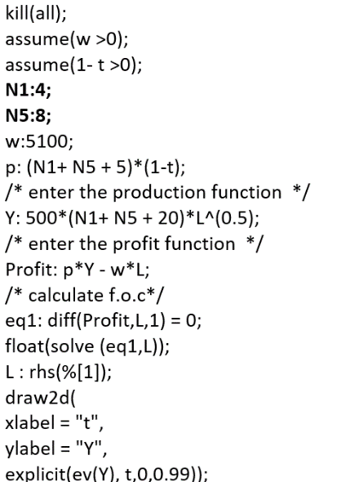

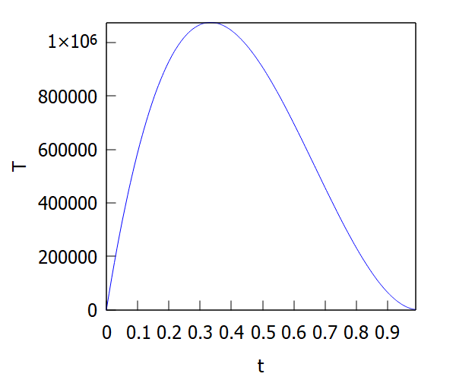It is a sort of Laffer curve. It is the tax revenue function T(t) with respect to the tax rate.

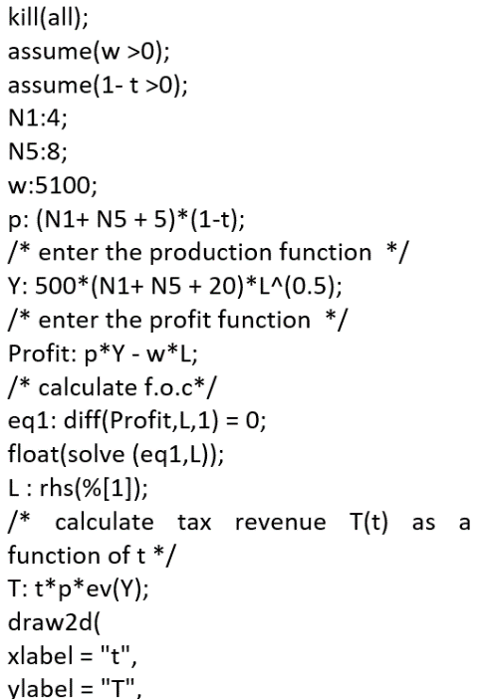

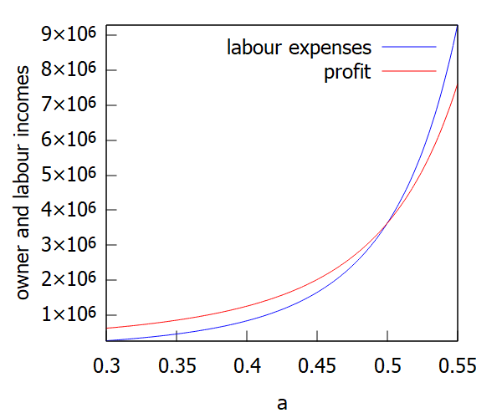Finally, something to think about: how the division of income between owners and employees depends directly on the production function parameter. An interesting and very significant relationship.

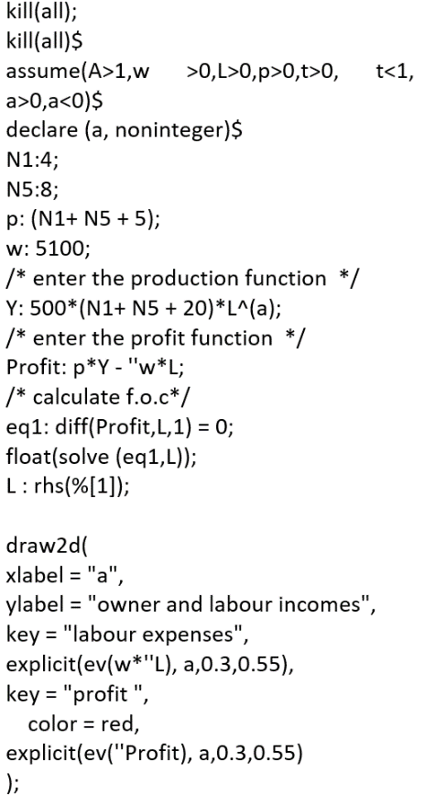

**Abdukholik Tukhtamishev**

**StudentId: 474886**